***LEBANESE HILL CLIMB CHAMPIONSHIP***

***GENERAL REGULATIONS***

***2018***

**VISA No. C1/2018 - Date 23/01/2018**



**Organised by**

The Automobile and Touring Club of Lebanon

P.O. Box 115 - Jounieh / Lebanon

Tel.: +961-9-640220 / 640567 / 932020

Fax: +961-9-640579 / 934662

e-mail: **atcl@inco.com.lb**

web site: **www.atcl.org**

**Contents:**

**Page**

**General Programme 3**

**1. Organisation 3**

**2. General Conditions 4**

**3. Eligible Vehicles 5**

**4. Drivers’ safety Equipment 7**

**5. Eligible Competitors and Drivers 7**

**6. Entries, Liability and Insurance 7**

**7. Reservations, Official Text 9**

**8. General Obligations 9**

**9. Administrative Checking and Scrutineering 11**

**10. Running of the Competition 12**

**11. Parc Fermé, Final Checks 14**

**12. Classifications, Protests, Appeals 15**

**13. Prizes and Cups, Prize-Giving Ceremony 16**

**14. Special Provisions 17**

**APPENDIX 1 Advertising and Identification Numbers 18**

**APPENDIX 2 Extracts from FIA Appendix L 20**

**APPENDIX 3 Start Light Sequence 21**

**GENERAL PROGRAMME:**

Opening Date of Entries

Close of Entries

Publication of the Entry List on the Official Notice board.

Practice session

Administrative Checks and Scrutineering - A.T.C.L.

Publication of the Start List.

Cars entry to the Starting Zone

Compulsory Briefing

**Race - 1st heat**

**Race - 2nd heat**

**Race - 3rd heat**

Publication of the Provisional Final Classification.

Publication of the Official Final Classification.

Prize giving

**The dates of the above mentioned programme will be determined in a bulletin issued for each Hill Climb race.**

1 - ORGANISATION

**1.1– General**

* + 1. The Sporting Authority of the Automobile & Touring Club of Lebanon organises the 2018 Lebanese Hill Climb Championship.
    2. TheLebanese Hill Climb Championship will be run in compliance with the provisions of the National Sporting Code and these supplementary regulations.
    3. These supplementary regulations have been approved by the National Sporting Authority with Visa No **C1/2018** dated **January 23rd 2018.**

**1.2 Organising Committee, Secretariat, Officials**

1.2.1.a- Organising Committee:

Chairman: Gaby Kreiker

Members: Raffi Khederlarian

Naaman HATEM

Nicolas HINDI

Lyan Tawtah

1.2.1.b- The address of the secretariat of the Championship is as follows:

The Automobile and Touring Club of Lebanon

Kaslik; Jounieh

National Sporting Committee

P.O. Box 115 - Jounieh / Lebanon

Tel.: +961-9-640220 / 640567 / 932020

Fax: +961-9-640579 / 934662

e-mail: [**atcl@inco.com.lb**](mailto:atcl@inco.com.lb)

web site: **www.atcl.org**

**Monday to Friday; from 08:00 to 16:30hrs**

1.2.2- Officials of the Hill Climb events

Stewards of the meeting (TBA in a bulletin preceding each race)

ASN Sporting Delegate: (TBA in a bulletin preceding each race)

Clerk of the Course: (TBA in a bulletin preceding each race)

Assistant Clerk of the Course: (TBA in a bulletin preceding each race)

Safety Officer: (TBA in a bulletin preceding each race)

Scrutineers: (TBA in a bulletin preceding each race)

Time Controllers: (TBA in a bulletin preceding each race)

Itinerary Officers: (TBA in a bulletin preceding each race)

Competitor's Relations Officers: (TBA in a bulletin preceding each race)

Media Relations Officer: Mr. Jalal BEAINO

Chief Medical Officer: (TBA in a bulletin)

Results Officer: Mr. Lian TAWTAH

Paramedics: Lebanese Red Cross

Administration: Mr. Michel El-Hayek

Equipment person in charge: Mr. Roger BASSIL

1.3– Official notice board(s)

All communications, decisions, amendments, numbered information bulletins, additional conditions as well as the results, shall be posted on the official notice board(s) located:

* From Monday until one day before the race at the secretariat of the event.
* During the day of the race, in the vicinity of racing track.

2 – GENERAL CONDITIONS

**2.1** The event shall be organised in conformity with the provisions of the 2018 FIA International Sporting Code (and its appendices), the National Sporting Code which comply with the F.I.A. Regulations and the provisions of these General Regulations

**2.2** By entering the competition, the Entrants agree to abide by the above provisions and abandon all recourse to arbitrators or courts not provided for in the International Sporting Code.

**2.3** This Hill Climb counts for the following national titles:

* The Lebanese Hill Climb Championship (Coefficient 1).
* The Lebanese Hill Climb Championship for Group N Drivers (Coefficient 1).
* The Lebanese Hill Climb Championship for Front Wheel Drive Category (Coefficient 1).
* The Lebanese Hill Climb Championship for Rear Wheel Drive Category (Coefficient 1).
* The Lebanese Hill Climb Cup for Junior Drivers.
* The Lebanese Rally Championship (Article 7.7.a of the 2018 National Sporting Code).

**2.4– Course**

This Hill Climb will be run according to the following:

1. Minimal distance: 2.5 Kms
2. Minimal slope average: 5%

3 – ELIGIBLE VEHICLES

**3.1– Classes and Groups**

The eligible vehicles to participate in hill-climb are:

3.1.a Class RC1 (WRC cars) as well as all vehicles’ classes described in Article 4.2 of the 2018 FIA Regional Rallies Championships Sporting Regulations. The vehicles concerned must be in conformity with Appendix J of the F.I.A International Sporting Code for the running year; *Refer to table below*:

Classes and Groups:

|  |  |
| --- | --- |
| **Classes**  **Classes** | **Groups** |
|  |  |
| **RC2/-N4** | S2000-Rally: 1.6 T engine with a 28mm restrictor |
| S2000-Rally: 2.0 Atmospheric |
| Group R5 (VR5) |
| Group R4 (VR4) (not eligible in Europe) |
| **RC2/N4** | Group N car over 2000cc (current N4) |
| **RGT** | *RGT cars are excluded |
| **RC3** | Group A car over 1600cc and up to 2000cc |
| Super 1600 |
| R2 (atmo over 100cc and up to 2000cc – VR2C  and turbo over 1067cc and up to 1333cc-VR2C) |
| R3 (atmo / over 1600cc and up to 2000cc – VR3C  And turbo over 1067cc and up to 1333cc-VR3C) |
| R3 (turbo / up to 1620cc / nominal – VR3T) |
| R3 (diesel / up to 2000cc / nominal – VR3D) |
| **RC4** | Group A up to 1600cc |
| R2 (atmo over 1390cc and up to 1600cc-VR2B  and turbo over 927cc and up to 1067cc-VR2B) |
| Kit-car up to 1600cc |
| Group N car over 1600cc and up to 2000cc |
| **RC5** | Group N car up to 1600cc |
| R1 (atmo up to 1600cc-VR1A/VR1B and turbo  up to 1067cc-VR1A/VR1B ) |

1. Groups A, WRC vehicles, and N cars or their equivalent Classes RC2 to RC5 whose homologations have expired, and still accepted by the FIA, up to a maximum of four years before the beginning of the current year, *i.e. Jan 1st 2014 up to Dec. 31st 2017.*
2. National Cars according to Article 4.4 of the 2018 FIA Regional Rallies Championship Sporting Regulations whose homologations have expired between five and ten years before the beginning of the current year, *i.e. Jan 1st 2008 up to Dec 31st 2013*
3. FIA Rally touring cars with extended eligibility for regional rallies.
4. It is MANDATORY for these vehicles within this category to be in conformity with their expired homologation forms and current FIA safety regulations.

3.1.b Group SM must be in conformity with Appendix C of the ASN National Sporting Code for the year 2018 (find here below).

Vehicles groups and classes are as follows:

SM1 Up to 1400 cm3

SM 2 Over 1400 cm3 and up to 1600 cm3

SM 3 Over 1600 cm3 and up to 2000 cm3

SM 4 Over 2000 cm3 and up to 3000 cm3

SM 5-2 Over 3000 cm3 and up to 3500 cm3 – 2WD

SM 5-4 Over 3000 cm3 and up to 3500 cm3 – 4WD

SM 6 Over 3500 cm3 and up to 4500 cm3

**3.2 Turbos & superchargers:**

* In conformity with the Appendix J, Article 254-4 of the 2018 FIA International Sporting Code, All Group N vehicles with supercharged engines must be fitted with a restrictor fixed to the compressor housing. The maximum internal diameter of the restrictor is 33mm.
* In conformity with the Appendix J, Article 255, of the 2018 FIA International Sporting Code, all Group A (including A8) vehicles with supercharged engines must be fitted with a restrictor fixed to the compressor housing. The maximum internal diameter of the restrictor is 34mm.
* In conformity to the Appendix J of the 2018 FIA International Sporting Code, all Group R supercharged vehicles must be fitted with a restrictor.
* In accordance with the Appendix C of the 2018 National Sporting Code, SM vehicles with supercharged engines must be fitted with a restrictor of maximum 38mm, (according to the drawing 254-4 of the appendix J). The external diameter of the restrictor at its narrowest point must be less than 44mm and must be maintained over a distance of 5mm to each side. For cars with twin turbo engines, each device should be fitted with a restrictor of maximum 24mm each.

**3.3 Vehicle equipment**

3.3.1 The safety equipment of all vehicles must comply with Appendix J of the 2018 FIA International Sporting Code, as well as Appendix C of the National Sporting Code for the year 2018.

3.3.2 Any vehicle with insufficient safety features or not complying with the regulations in force shall not be admitted to or shall be excluded from the event.

**3.4 Fuel:**

3.4.1 **Only UNLEADED fuel is admitted in Lebanon.**

3.4.2 In addition to aviation fuel (AVGAS), commercially available petrol or diesel according to the provisions of Article 259.6.1 of Appendix J, are only permitted as fuel.

3.4.3 Only air can be mixed with the fuel as an oxidant.

**4 – DRIVERS' SAFETY EQUIPMENT**

**4.1** The wearing of a safety belt and a crash helmet complying with the standards approved by the FIA is obligatory during the practice heats and the race.

**4.2** Drivers are strictly obliged to wear fire-resistant overalls (including a mask or balaclava, gloves, under wears, socks, boots & frontal head restraint system – FHR *(i.e. HANS Device etc.)* complying with the current FIA standard.

**4.3** The control of the drivers’ equipments will take place at the scrutineering, and at any time during the practice and/or the race.

5 – ELIGIBLE COMPETITORS AND DRIVERS

**5.1** Any person or legal entity holding a competitor's licence valid for the current year by the ATCL is accepted and eligibly recognised.

**5.2** Drivers must also be in possession of a current Lebanese driving licence and a competition licence valid for the current year.

**5.3** In accordance with Article 3.9.4 of the 2018 FIA International Sporting Code, foreign competitors and drivers, with international licences, must be in possession of a written authorisation to take part in the event from the ASN which issued them with their licence(s).

6 – ENTRIES, LIABILITY AND INSURANCE

**6.1** Any person who wishes to participate in the 2018 Lebanese Hill Climb Championship events has to submit his (her) participation, in accordance with the issued bulletins to the secretariat of the Championship, between 09:00hrs and 16:00hrs at:

The Automobile and Touring Club of Lebanon (A.T.C.L.)

National Sporting Committee

P.O. 115 Jounieh - Lebanon

Phone. (961-09) 640220 - 640567

Fax: (961-9) 640579

e-mail**: atcl @ inco.com.lb**

The Closing date for entries will be in accordance with the issued bulletins.

If the entry form is sent by fax or e-mail, the original entry form must reach the Organiser before the close of entries.

**6.2** The maximum number of entrants is limited to 50 cars.

**6.3** There may be a change of vehicle after the close of entries and up to the time of the administrative checks of any concerned competitor, provided that the new vehicle belongs to the same Class and Group (Article 3.1) as the vehicle being replaced.

**6.4** No change of competitor may take place after the close of entries. Changes of driver are authorised in accordance with Article 9.13 of the 2018 FIA International Sporting Code. The replacement driver, who must hold a valid licence (national or international) as well as an authorisation from his ASN (for international competitors), must be named before the administrative checks are carried out for the vehicle concerned. However, an additional fee of 100- U.S. $ will be imposed.

**6.5** At the time of scrutineering, if a car as presented does not correspond to the Class and/or Group in which it was entered, the Stewards may transfer it to the appropriate Class and/or Group recommended by the scrutineers or be refused definitively.

**6.6** Double starts (1 driver for 2 vehicles or 1 vehicle for 2 drivers) are not authorised.

**6.7** The Organising committee reserves the right:

1. To refuse an entry, without having to give the reasons for its decision (Article 3.14 of the 2018 FIA International Sporting Code).
2. To cancel the event if the number of the competitors is less than 15 cars.
3. To cancel the trophy concerning a given group if the number of cars in the group is less than 3

**6.8 Entry fees**

6.8.1 The entry fees are fixed thus to:

1. Two hundred & fifty U.S. Dollars (250- U.S. $) for competitors, persons and/or legal entity, that accept the optional advertising proposed by the organisers (Article 8.3.3).
2. Five hundred U.S. Dollars (500- U.S. $) for competitors, persons and/or legal entity, that do not accept the optional advertising proposed by the organisers (Article 8.3.3).
3. For teams, the entry fees are fixed to two hundred & fifty U.S. Dollars (250 U.S. $) for each registered vehicle.

6.8.2 An entry shall only be accepted if it is accompanied by the entry fees and received by the deadline set in Article 6.1.

6.8.3 In all cases, the entry fees include the competitor's and Driver's Civil Liability insurance premium, as well as the necessary Competition numbers.

6.8.4 Entry fees will be refunded in full:

1. To candidates whose entry has not been accepted,
2. In the case of the event not taking place.

**No reimbursements will be made except for the above mentioned.**

**6.9 Liability and insurance**

6.9.1 Foreign Entrants’ insurance fee is 135 US $. This guarantees the competitor cover for medical expenses of up to 15.000 US $ and death & disability insurance of 30.000 US $ according to the insurance policy.

However, the organiser shall refuse to accept any liability for damage to property vis-à-vis Competitors, Drivers, assistants and third parties.

Beside the insurance provided by the organisers, it is compulsory for all entrants / competitors to have their vehicle covered by a third party liability.

A copy of the insurance certificate should be presented along with other documents upon administrative checking (refer here under to Art. 9.1.3 of these Supplementary Regulations).

6.9.2 The entry fees include the insurance premium, which guarantees the competitor cover against Civil Liability towards third parties up to 25.000- US $ for each case;

6.9.3 The Civil Liability insurance taken out by the organiser applies for the entire duration of the event.

6.9.4 The insurance cover will come into effect at the start of the event and will cease at the finish of it, at the moment of retirement, and/or exclusion.

6.9.5 If a driver taking part in the event is involved in an accident he/she must report this as soon as possible to the Competitors’ Relations’ Officer(s).

6.9.6 In case of car breakdown the competitors bear the transportation and/or towing fees.

**7 – RESERVATIONS, OFFICIAL TEXT**

**7.1** The Organiser, or the Stewards, reserves the right to make modifications, amendments and/or changes to these General Regulations which will be announced only by numbered and dated bulletins, and will form an integral part of them. The Entrants shall be informed of these additional conditions as soon as possible, and the bulletins shall be posted on the official notice board (Article 1.3).

**7.2** The Organiser, or the steward also reserves the right to cancel or stop the event in the case of insufficient participation (Article 6.7.a), force majeure or unforeseeable events, without being under any obligation whatsoever to provide compensation.

**7.3** Any cases not provided for in the General Regulations shall be decided by the Stewards.

**7.4** In case of dispute concerning the interpretation of these regulations, only the English text will be binding.

**8 – GENERAL OBLIGATIONS**

**8.1 Competition numbers**

8.1.1 The organiser shall provide each Entrant with 3 sets of Competitionnumbers, which shall be clearly displayed on both sides of the vehicle and the front bonnet *(refer to Appendix 1 hereafter)* throughout the duration of the competition. Vehicles without correct Competitionnumbers will not be allowed to start the competition.

8.1.2 The first initial and surname of the driver, followed his the national flags of the country of the ASN from which they have obtained their licence, must appear on the rear side window on both sides of the car. The names must be:

* In white Helvetica;
* In upper case for the initial(s) and first letter of each name with the remainder in lower case;
* 6cm high and with a stroke width of 1.0 cm.

8.1.3 The Entrants can on no account make any modification(s) to the shape, the dimension or the contents of these sets of numbers under pain of exclusion

8.1.4 The Organiser shall be responsible for allocating the competition numbers.

8.1.5 At the end of the competition, before leaving the Parc Fermé, the numbers of vehicles driving must be removed.

**8.2 Starting arrangements**

8.2.1 Drivers must place themselves at the disposal of the clerk of the course at least one hour before the start. The drivers shall accept the consequences should they be unaware of any conditions or modifications to the timetable which might be decided prior to the start.

8.2.2 The drivers shall take their place at the “Start” area in a due time assigned by the event officials, time keepers and/or marshals. Any driver who fails to report to the “Start”, at his given starting time, will be reported to the Stewards who may impose penalties which may go as far as exclusion.

**8.3** **Advertisement**

8.3.1 The used places for advertising purposes are free with the exception of those reserved for the competition numbers, the logo of the Championship as well as that of the Organisers

8.3.2 Competitors are allowed to affix any kind of advertising to their vehicles, provided that:

1. It is authorised by the FIA regulations and the legislation of the countries crossed,
2. It is not likely to give offence,
3. It does not encroach upon the spaces defined below reserved for plates, race numbers and windscreen strips,
4. It does not interfere with the driver’s vision through the windows.
5. **The advertising of political, religious and/or social material is strictly forbidden**. Any breach of this rule will be reported and may result in a penalty, at the discretion of the Stewards (Article 12.2 of the Code), which may go as far as exclusion.
6. Cars must be presented to the scrutineers with the competition numbers, front plates and optional advertising affixed on the car before entering the Scrutineering venue. Failing to comply with this rule is subject to a cash penalty of 100. - U.S. Dollars.

**However, No advertising whatsoever may be affixed to the side and rear windows.**

8.3.3 Optional Advertising: by the Organisers (reduced fees, Article 11.1)

1. On the upper part of the windscreen.
2. One space on each Front Door of the vehicle **(67cm x 25cm)** situated below the side race numbers. A further bulletin will determine the brands.

**8.4 Flag signals, track behaviour**

8.4.1 The following flag signals may be used during practice and the race, and must be strictly observed:

|  |  |
| --- | --- |
| **Red flag:** | Stop immediately and definitively. |
| **Black and white chequered flag:** | End of the heat (finish line). |

The Chequered flag will be applicable at the end of the heats (finish line)

8.4.2 It is strictly forbidden to drive a vehicle across or in the opposite direction to the direction of the race, unless instructed to do so by the track marshals or the clerk of the course. Any breach of this regulation shall result in immediate exclusion pronounced by the Stewards, with the possible addition of other sanctions and the transmission of the case to the ASN concerned.

8.4.3 If a driver is obliged to stop his heat owing to mechanical failure or other problems, he must immediately park his vehicle away from the track and leave it, and obey any instructions given by the track marshals.

**9 – ADMINISTRATIVE CHECKS AND**

**SCRUTINEERING**

**9.1 Administrative checks**

9.1.1 The administrative checks will take place according to a separate timetable given later in a bulletin and posted on the official notice board at the Automobile Touring Club of Lebanon – Jounieh, Lebanon.

9.1.2 All competitors and drivers taking part in the Hill Climb **must report for administrative checks in person** with their cars **in their precise scheduled time** as shown on the list displayed on notice board, failing to do so, a penalty will be imposed as per article 14.1.3.

9.1.3 The administrative checks will consist of checking the following documents:

1. Control of the entrants’, competitors’ and drivers’ competition and road licences and its validity for the current year.
2. Control of the registration and the characteristic data of the car (brand, model, category, group, engine capacity, etc…).
3. For eligible cars in compliance with Article 3.1.a of these regulations, control of the homologation papers, technical passport *(if any)*, etc…
4. Insurance policy covering the competing vehicle.
5. Foreign entrants must also present written authorisation from their ASN, if this was not enclosed with their entry.

Entrants are obliged to be present for the administrative checks so that identification and administrative checking can be carried out.

Those who have passed the administrative checks and having received the approval signed by the officials can present their car to scrutineering in accordance with the published timetable as shown on the official notice board.

**9.2. Scrutineering**

9.2.1 The scrutineering will take place according to a separate timetable given later in a bulletin and posted on the official notice board at the Automobile Touring Club of Lebanon – Jounieh, Lebanon.

9.2.2 Entrants are obliged to accompany their vehicle at scrutineering, so that identification and safety checks can be carried out.

9.2.3 The complete original FIA homologation form for all homologated vehicles must be presented in addition to the authentic roll cage certificate. Otherwise, scrutineering will be refused. For Group SM cars, a roll cage certificate must be presented, no homologation forms are needed.

9.2.4 Entrants reporting for scrutineering after their scheduled time shall be liable to a penalty which may go as far as exclusion, at the stewards' discretion.

However, the stewards may decide to allow the vehicle to a postponed scrutineering if the competitor/driver can prove that their late arrival was due to force majeure.

9.2.5 Scrutineering does not constitute confirmation that the vehicle complies with the regulations in force.

9.2.6 After scrutineering has been completed, both the “List of Entrants Authorised to Take the Start” and the “Start List” shall be published and posted by the Organiser on the official notice board at The Automobile and Touring Club of Lebanon - Jounieh; Lebanon.

9.2.7 Cars must be presented to the scrutineers with the competition numbers; *(refer to article 8.3.2.f here above)*.

**10 – RUNNING OF THE COMPETITION**

**10.1 Start, finish, timekeeping**

10.1.1 The start will take place individually for each driver with the vehicle stationary and the engine running. The minimal interval between the starts will depend on the length the course.

The stewards of the meeting and the clerk of the course are free to modify the starting order according to the circumstances.

10.1.2 Start order should be by Classes and in an ascending method; i.e. RC1, SM1, RC2, SM2…. and so on. No vehicle may take the start outside its own class unless expressly authorised to do so by the Stewards.

10.1.3 The start interval will be max 2 minutes (2 min.) for each car and for all competitors.

10.1.4 The start of the heats will be carried out by an electronic countdown system, placed on the left hand side of the road, between 2 and 5 meters ahead of the starting line, counting down by seconds and clearly visible to the driver from the start position; *refer to Appendix 3 hereafter*. Should the above starting light panel fail to function the start, the start marshal will count down aloud: 30" - 15" - 10" and the last five seconds one by one. When the last 5 seconds have elapsed, the starting signal shall be given.

MODIFICATIONS APPLICABLE ON 01.01.2018

The electronic start procedure is coupled to an electronic jump start detection system. This system is electronically coupled to a start line detection device that records any situation where a car leaves the start line ahead of the correct signal (false start). A false start will incur a penalty of 5 seconds pronounced by the clerk of the course.

10.1.5 Any refusal or the delay of 20 seconds in taking the start shall result in exclusion.

10.1.6 Any vehicle which has triggered the timing apparatus shall be considered as having started, and shall not be granted a second start.

10.1.7 The finish shall be a flying finish. The heat ends when the vehicle crosses the finish line; as soon as this is done, the driver must reduce the vehicle speed drastically- At the end of each heat, **the competitor has to present his/her vehicle into the Parc Fermé within the time allowed given by the marshals and previously agreed upon in the compulsory briefing before the start of the event**. The Competitor will follow the organizer’s instructions in order to start another heat. **Competitors reporting late to the Parc Fermé will be penalized 10. - U.S. $ per minute to maximum of 15 minutes. Thereafter, they will result in exclusion pronounced by the Stewards of the Meeting.**

10.1.8 Timing shall be carried out using photocells accurate to at least 1/100 of a second.

**10.2 Practice**

Practice session is set to One Day, in which each competitor has the right to run ONLY three heats (3) and shall take place in accordance with the detailed timetable drawn up by the organiser (Chapter I - General Programme of the Event).

It is strictly forbidden to practice outside the times scheduled by the Organiser. Any breach of this rule will be submitted to the Stewards and will result in a penalty, which may go as far as exclusion, at the discretion of the Stewards (Article 12.2 of the Code).

**It is mandatory for all competitors to run their practice according to the following:**

1. **using the entered vehicle**
2. **Wearing complete FIA drivers’ equipment complying with Appendix L of the 2018** **International Sporting Code.**
3. **The presence of a passenger in the vehicle during practice is PROHIBITED, and will result in immediate exclusion from the event.**

**10.3 The race**

10.3.1 The heats of the race shall take place in accordance with the detailed timetable drawn up by the Organiser (General Programme of the Event).

10.3.2 The Lebanese Hill Climb Championship – 2018 shall be run over three (3) events of three (3) heats each.

10.3.3 The clerk of the course based on the decision of the stewards of the meeting may authorise the drivers whom are stopped on the course due to unknown problems to take another start on the next heat. No complaint will be admitted on this subject. All drivers during the heats should abide by the decisions taken by the clerk of the course.

Any breach of the rules reported to the clerk of the course and upon the decision of the stewards of the meeting could result in the competitor being excluded from the event.

10.3.4 A general briefing will be held as previously scheduled in bulletins. The presence of all drivers is compulsory. During the briefing the competitors will receive the latest instructions concerning the event.

10.3.5 Tyre warming:

For the year 2018:

A distance of twenty five meters (50 meters.), at the discretion of the clerk of the course, will be preserved for the competitors before the Start Line. Each driver has the right to **MODERATELY** drive it **ONE WAY** and **ONCE** towards the Start Line while warming his tyres. They shall fully follow the instructions of the marshals in charge of this area. Any breach of this rule will incur a penalty of 5 seconds pronounced by the clerk of the course.

MODIFICATIONS APPLICABLE ON 01.01.2019

Any form of pre-heating of the tyres before the start is prohibited and may result in sanctions that may go as far as exclusion.

Any competitor found in breach of this rule will be reported to the stewards, and may result in a penalty, at their discretion (Article 12.2 of the Code), which may go as far as exclusion.

10.3.6 **Each competitor should finish his heat within 10 minutes otherwise he is disqualified from the intended heat.**

**10.4 Outside assistance**

10.4.1 Any outside assistance shall result in exclusion.

10.4.2 Vehicles which have broken down along the route may only be towed away by order of the clerk of the course.

10.5 The tyres used on homologated cars that are in accordance with Article 4.2 of the 2018 FIA Regional Rally Sporting Regulations, must comply with Article 60 of the same Sporting Regulations and read in conjunction with Appendix V, Article A - Tarmac Tyre Regulations. The list of eligible asphalt tyres for FIA rallies, which are the only tyres allowed, can be found on the FIA website under the following link:

<http://www.fia.com/regulation/category/117>

**11 – PARC FERME, FINAL CHECKS**

**11.1 Parc Fermé**

11.1.1 At the end of the Competition, Parc Fermé rules shall apply between the finish line and the entrance to the Parc Fermé.

11.1.2 At the end of the Competition, all classified vehicles shall remain in the Parc Fermé until indication to the contrary is given by the clerk of the course with the approval of the stewards. Parc Fermé rules shall not be lifted until the period of time allowed for the lodging of protests has expired.

11.1.3 The Final Parc Fermé will be located at the vicinity of the race track.

**11.2 Additional checks**

11.2.1 Any vehicle may be subjected to additional checking by the scrutineers, both while the Competition is taking place and especially after the finish. At any time during the event technical checks can be carried.

11.2.2 At the request of the stewards, whether spontaneously or following a protest, a vehicle may be impounded after the finish and subjected to complete and detailed scrutineering entailing the dismantling of the vehicle

**12 – CLASSIFICATIONS, PROTESTS, APPEALS**

**12.1 Classifications**

12.1.1 The provisional results will be published after the last competing car finishes its heat.

12.1.2 The final official results will become definitive within half an hour following the posting of the provisional results if no protest was received.

12.1.3 The conditions for drawing up the classifications are as follows:

The driver **with the least cumulate time achieved in TWO heats out of the THREE possible intended heats** will be declared winner. Nevertheless, the second will be the one that will have a time superior to the first but less than that of the 3rd, etc.

12.1.4 The rule for deciding between Competitors in the case of a dead heat is as follows:

In case of a tie, the best time set during the 1st race heat between the two competitors will determine the winner. (Ref to International sporting code & National sporting Code)

**12.2 Protests**

**Protest time limit shall be in compliance with the Article 13.3 of the 2018 FIA**

**International Sporting Code.**

**12.3 Appeals**

12.3.1 The lodging of an appeal and the related costs shall be in accordance with the provisions of the International Sporting Code.

12.3.2 The deposit for national appeals is set to 4,000-US$ in accordance with the stipulations specified in the National Sporting Code for the year 2018.

**13 – PRIZES AND CUPS, PRIZE-GIVING CEREMONY**

**13.1. Prizes and cups**

13.1.1 The following prizes, cups and trophies shall be awarded:

1. General Classification

First: 1 Trophy

Second: 1 Trophy

Third: 1 Trophy

1. Front Wheel Drive Category

First: 1 Trophy

Second: 1 Trophy

Third: 1 Trophy

1. Rear Wheel Drive Category

First: 1 Trophy

Second: 1 Trophy

Third: 1 Trophy

1. Group N:

First: 1 Trophy

Second: 1 Trophy

Third: 1 Trophy

1. Junior Cup 1 Trophy
2. First by Class 1 Trophy
3. Ladies Cup 1 Trophy

13.1.2 Prizes in kind must be collected in person at the prize-giving ceremony; otherwise they shall remain the property of the organiser.

13.1.3 A driver may win any number of prizes.

**13.2 Prize giving ceremony**

13.2.1 It is a point of honor that all participants should attend the prize-giving ceremony.

13.2.2 The prize giving shall take place on the vicinity of the track.

13.2.3 Competitors that are not personally present at the prize giving ceremony **along with their vehicles** will loose their right over their prizes. Nevertheless, the classification and attribution of the other prizes won’t be modified.

**14 – SPECIAL PROVISIONS**

**14.1 Penalties**

14.1.1 Exclusion:

1. Absence of the crash helmet or safety belt.
2. False information in the entry form.
3. Replacing of driver or in case of retirement.
4. Vehicles not entering the Parc Fermé at the end of the event.

14.1.2 Start refused:

No vehicle will be allowed to start unless it complies with the FIA safety regulations.

14.1.3 All competitors/drivers taking part in the Hill Climb Championship – 2018 must arrive at scrutineering and/or administrative checks in at their precise time as shown on the list displayed on the official notice board. Failure to do so will incur in a cash penalty of U.S. $ 25.00 for each 15 minutes and/or a fraction of 15 minutes up to a maximum of 30 minutes, after which they will be reported to the Stewards who may impose a penalty which may go as far as exclusion.

14.1.4 All competitors/drivers taking part in the Hill Climb Championship– 2018 must present their vehicles to the Paddock (s) or Parc Fermé. Failure to do so will incur in a cash penalty of **10. - U.S. $ per minute to maximum of 15 minutes. (Please refer to Art. 10.1.4 here above)**

**14.2** In accordance with Appendix A of the National Sporting Code, all Competitors, teams and entrants who wish to carry on-board cameras, in-car videos and/or film cameras must have the prior agreement of the Organisers. **However, it is MANDATORY to provide the Organisers and/or the Clerk of the Course with a copy of the recordings upon requisition.**

**14.3** Onboard and event Media Footage is a property of the ATCL and an authorisation from the Organiser is requested by all media before any transmission.

**APPENDIX 1:**

**IDENTIFICATION numbers, advertising and NAMES**

**Identification Numbers and Compulsory Advertising:**

1 2 x Door Panel with Competition Number 67x17cm. The top of the plate shall be placed between 7 cm and 10 cm below the bottom window line. No other signage shall be placed within 10 cm of the plate. **(1)**

2 Front Competition Plate 43x21.5cm. **(2)**

3 Rear side windows - *refer to Article 8.1.2*: **(3)**

The name of the driver with his/her passport nationality national flag must appear on the rear side window of both sides of the car (under the Competition Numbers). The Surname alone shall be:

3.1 In Helvetica upper case for the first letter of the name and the remainder in lower case

3.2 In white on a clear background.

3.3 To a height of 6 cm. and a stroke width of 1cm.

3.4 Flag height 6 cm.

**Organisers’ Optional Advertising:**

1 A 10cm. high strip on the upper part of the windscreen, according to Article 15.7 of the International Sporting Code **(4)**.

2 One space on each Front Door of the vehicle (67cm x 25cm) situated below the number plate **(5)**.

A further bulletin will determine the advertising brands.

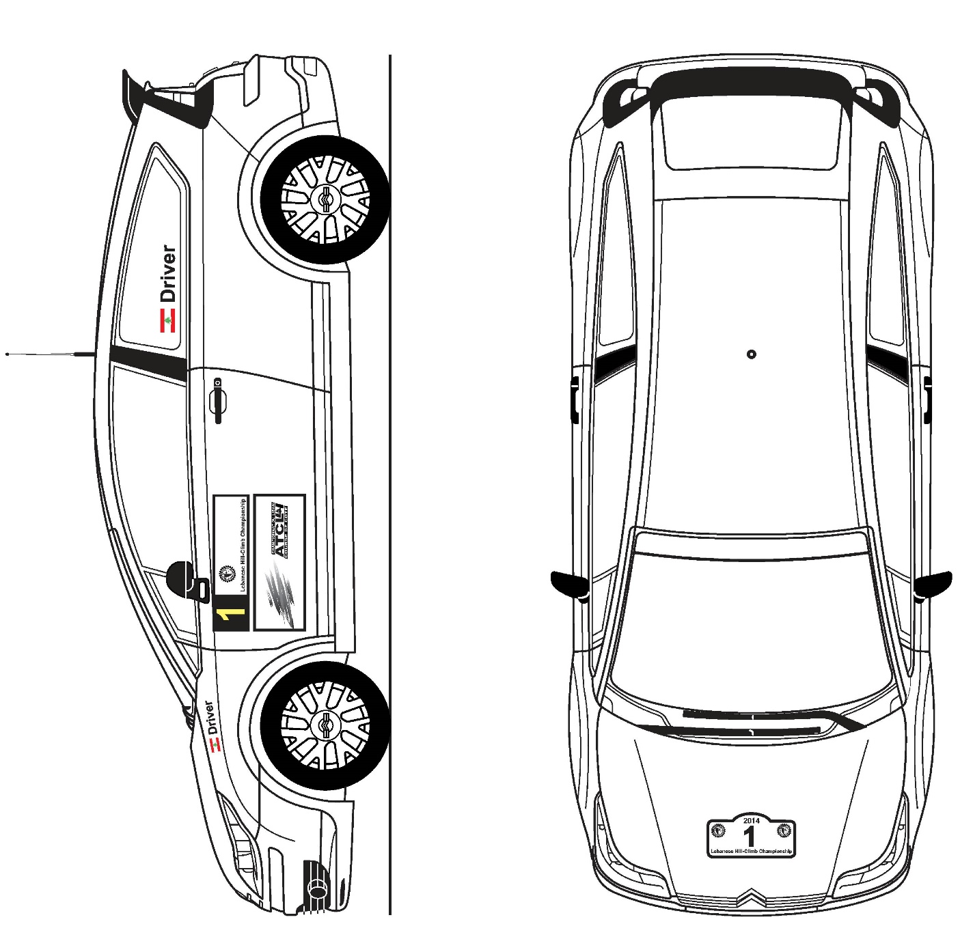

**APPENDIX 2:**

**Extracts from FIA Appendix L**

**1. Helmets**

All drivers must wear crash helmets which meet one of the standards listed in FIA Technical List N° 25.

**2. Flame-resistant clothing**

All drivers must wear overalls as well as gloves, long underwear, a balaclava, socks and shoes homologated to the FIA 8856-2000 standard (Technical List N°27).

Users must ensure that garments are not too tight, as this reduces the level of protection.

Embroidery sewn directly onto the overalls shall be stitched onto the outermost layer only, for better heat insulation. Backing material of badges and thread used for affixing them to the overalls must be flameproof.

**3. Frontal Head Restraint (FHR)**

The wearing of any device intended to protect the head or neck and attached to the helmet is prohibited, unless the device has been homologated according to the FIA 8858 standard. Homologated FHR systems are listed in the FIA Technical List N° 29.

FHR systems must be worn only with FIA-approved items according to the following chart:

|  |  |
| --- | --- |
| **Helmet / FHR** | **Tether system**  **(tether, tether end fitting and helmet anchorage)** |
| FIA 8860 (Technical List Nº 33)  FIA 8858 (Technical List Nº 41) | FIA 8858 (Technical List Nº 29) |

For more details when the device used is the HANS®, the “Guide for the Use of HANS® in international motor sport”, published by the FIA Institute for Motor Sport Safety, can be found on www.fia.com, under the heading FIA Sport - Regulations - Drivers’ Equipment.

**4. Safety Belts**

Drivers must be properly restrained in their seat by safety belts in conformity with the specifications of Appendix J for the vehicle concerned, at all times during an event when it is mobile on a circuit, pit lane, special stage or competition course.

Only FIA 8853/98 & 8853-2016 Harnesses are accepted. 8854/98 harnesses are not accepted anymore.

**APPENDIX 3:**

**START LIGHT SEQUENCE**

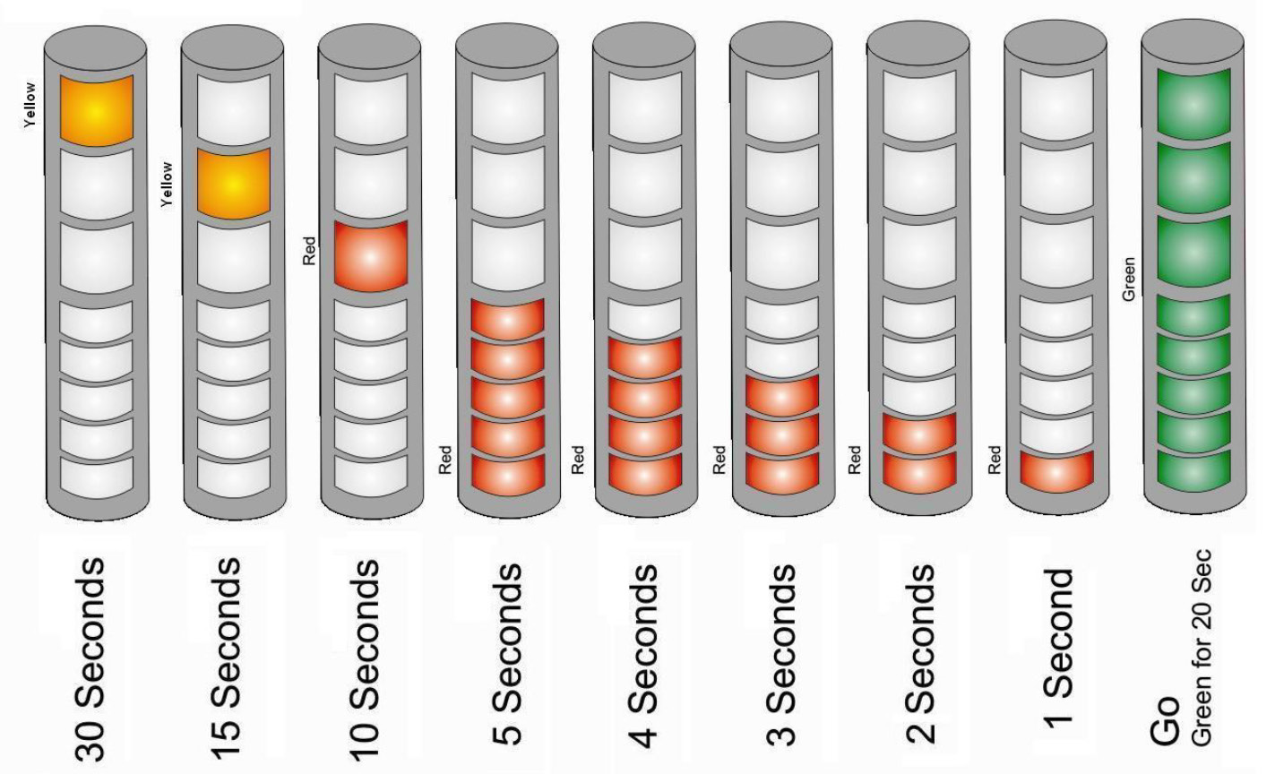

**This page has been left blank intentionally**